National Textile University, Faisalabad

Department of Computer Science
Name | Dawood Saif
Class | SE-6th (A)
Reg. No. | 23-NTU-CS-1145
Course | Mobile Application Development
Submitted To | Sir Rehan Sarwar
Submission Date | 12/05/2026
Lab Plan | Lab Evaluation

Lab Task: My Daily Schedule App
Build a Flutter app that displays your class schedule for the day. The app must show a clean, readable list of classes with their times and room numbers.
Requirements
- AppBar
• Title text should display: "My Schedule"
• Include a theme toggle button (light/dark mode switch icon)
- Schedule Cards
• Display 3 to 4 class cards
• Each card must contain:
• Time slot — e.g., 8:00 - 9:30 AM
• Subject name — e.g., Flutter Development
• Room number — e.g., Room 201
• Use Flutter's Card widget with Text widgets inside
- Layout
• Use a Column widget to arrange all schedule cards vertically
• Use SizedBox to add spacing between cards
• Apply padding around the content
• Both light mode and dark mode must look correct

Expected Output
Your app should display a list similar to the example below:
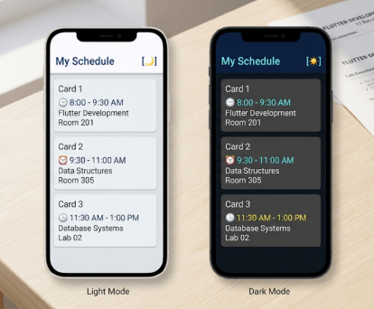

Code:
import 'package:flutter/material.dart';

void main() {
runApp(const MyApp());

}
const List<Map<String, String>> scheduledata=[
{
"time":"8:00 AM - 9:30 AM",
"subject":"Flutter Development",
"room":"201",
},
{
"time":"9:30 AM - 11:00 PM",
"subject":"Data Structures",
"room":"303",

},
{
"time":"11:30 PM - 1:00 PM",
"subject":"Database Systems",
"room":"Lab 02"
},

];
class MyApp extends StatefulWidget {
const MyApp({super.key});

// This widget is the root of your application.
@override
State<MyApp> createState() => _MyAppState();
}

class _MyAppState extends State<MyApp> {
bool isDarkMode=false;

void _toggletheme(){
setState(() {
isDarkMode=!isDarkMode;
});
}
@override
Widget build(BuildContext context) {
return MaterialApp(
title: 'my schedule',
debugShowCheckedModeBanner: false,
themeMode: isDarkMode ? ThemeMode.dark : ThemeMode.light,
theme: ThemeData(
colorScheme: ColorScheme.fromSeed(
seedColor: Colors.teal,
brightness: Brightness.light,
),
useMaterial3: true,
),
home: Schedulescreen(isdark: isDarkMode, ontoggletheme: _toggletheme,),
);
}
}

class Schedulescreen extends StatelessWidget {
final bool isdark;
final VoidCallback ontoggletheme;
const Schedulescreen({super.key, required this.isdark, required this.ontoggletheme});

@override
Widget build(BuildContext context) {
return Scaffold(
appBar: AppBar(
title: const Text('My Schedule', style: TextStyle(fontSize: 24, fontWeight: FontWeight.bold),),
centerTitle: false,
actions: [
IconButton(
icon: Icon(isdark ? Icons.dark_mode : Icons.light_mode),
onPressed: ontoggletheme,
),
],
),
body: ListView.builder(
itemCount: scheduledata.length,
itemBuilder: (context, index) {
final schedule = scheduledata[index];
return Card(
margin: const EdgeInsets.symmetric(horizontal: 16, vertical: 8),
child: ListTile(
title: Text(schedule['subject'] ?? 'No Subject', style: const TextStyle(fontSize: 18, fontWeight: FontWeight.w500),),
subtitle: Column(
crossAxisAlignment: CrossAxisAlignment.start,
children: [
Text(schedule['time'] ?? 'No Time', style: const TextStyle(fontSize: 14, color: Colors.grey),),
if (schedule.containsKey('room'))
Text('Room: ${schedule['room']}', style: const TextStyle(fontSize: 14, color: Colors.grey),),
],
),
),
);
},
),
);
}
}

On Light Mode:
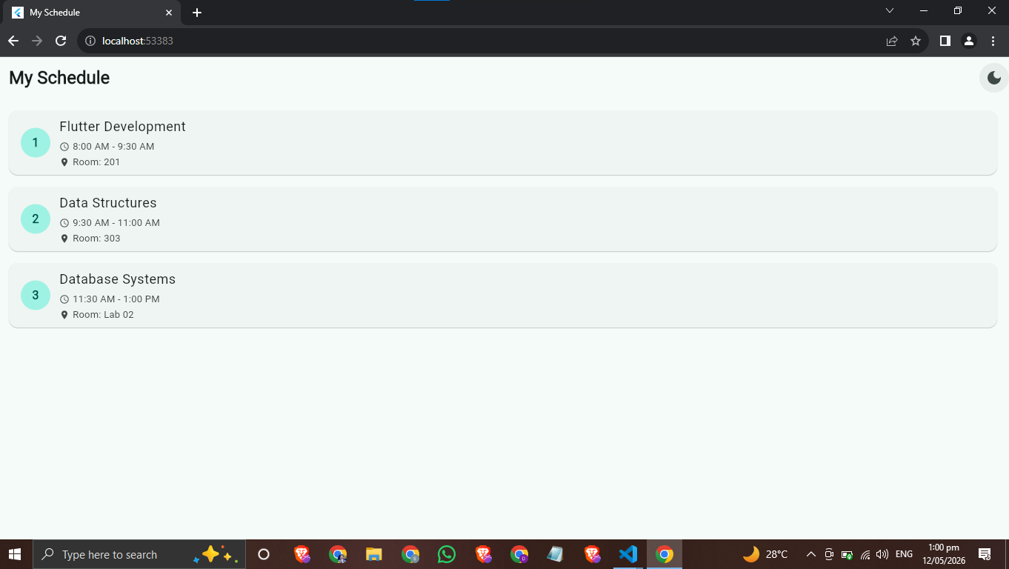

On Dark Mode:
